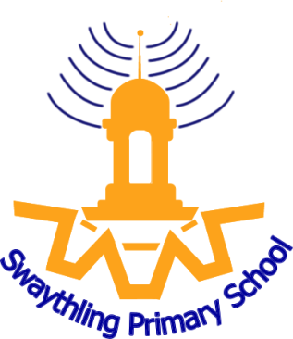
- Closing Date: 23rd May 2022 (12 noon)
- Interview Date(s): 27th May 2022
- Job Start Date: September 2022
- Contract/Hours: Full time
- Salary Type: Main Pay Range
- Hours of Work: Full time
- Location of Role: Swaythling Primary School, Southampton
- Contact e-mail address: info@swaythlingprimary.org

Job/Person Summary
We are seeking to appoint an enthusiastic teacher to join our popular community school.
The school is a part of the Aspire Community Trust- a co-operative trust of city maintained schools
What is it like to attend this school? Pupils are happy and enjoy learning. They like coming to school because teachers help them to understand what they are learning. Pupils benefit from the many trips and visitors to the school that bring their learning to life. (OFSTED 2020)
We are seeking to recruit a great teacher who:
- Is a reflective practitioner who motivates and challenges children to be their best
- Has high personal standards and sets high expectations of achievement, character and behaviour for all
- Has a drive to understand how all children learn best and demonstrates great learning themselves
- Is hardworking and committed to create a rich learning environment
- Demonstrates flexibility, integrity, resilience and initiative
- Has a good sense of humour
- Is able to work effectively as part of a team
- Is creative in their approach to a rich curriculum.
- Has excellent communication, organisational and interpersonal skills.

We can offer you:
- The opportunity to work in an exciting learning environment, as part of a trust which includes primary, infants and nursery, special, junior, secondary and special schools, who all work together in genuine collaboration
- A caring, friendly environment where there is a genuine commitment to raising standards of learning for all
- The chance to make a real difference to the lives of our pupils and their families
- A strong, professional team of enthusiastic staff to work alongside you within a supportive and constructive ethos where CPD is a very high priority.
- Exceptional CPD and promotion opportunities made possible by our membership of the trust.

Our teachers and support staff are professional, committed and excited about all our school has to offer, so we would be very interested to receive applications from similar individuals, whether highly experienced or recently qualified.

Application Procedure
Application packs are available on the school website https://swaythlingprimary.net/vacancies/ or you can request a pack by emailing recruitment@swaythlingprimary.org. If you require further details or wish to arrange a school visit please call the School Office on 023 8055 2252.

